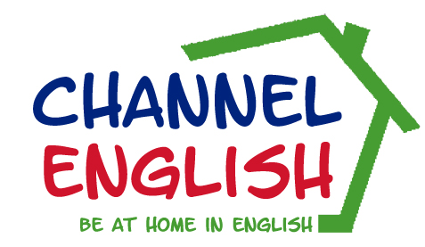
20200

Personal and Academic - Please complete
Family Name |  |  |  |  |  |  |  | First Name
Home Address:
Email Address:
Telephone |  |  |  | Mobile: |  |  |  | Home:
Nationality |  |  |  |  |  |  |  | Native Language
Sex (male/female) |  |  |  |  |  |  |  | Date of Birth
Do you smoke? |  |  |  |  |  |  |  | Do you object to smokers?
Do you object to young children? |  |  |  |  |  |  |  | Are you allergic to cats/dogs?
Health problems/allergies? Yes/No  Any special dietary requirements? Yes/No  Any medicines carried? Yes/No  If yes - please give details.  (Headed certificate signed by your family doctor required.) |  |  |  |  |  |  |  | Details:
Interests and hobbies

Level and Skills
LEVEL OF ENGLISH? |  |  |  |  | Speaking |  | Listening |  |  | Reading |  |  |  |  | Writing
From 1 to 10
(1 low/10 high)
Mark in class

Name of school/university
Please give details of any academic courses you are following, or examinations studied for:

Have you attended a Channel course before, if so when?

Dates and Duration (All courses begin on Sunday and end on Saturday)
Date of Arrival |  |  |  |  |  |  |  |  |  |  |  | Number of weeks  [ ] weeks
Date of Departure

Arrival Details and Taxi Transfers
Do you require a taxi transfer to/from your host family? |  |  |  |  |  |  |  |  | YES |  |  | NO
If yes, taxi fare to be paid directly to the driver in GBP sterling.

GENERAL AND JUNIOR COURSES
One to one |  | Two to one |  |  |  |  | Name of person you  are sharing with
Hours tuition per week |  | 10 |  |  |  |  | 15 |  |  |  | 20 |  |  |  |  | 25
IN ENGLISH, please write a short description of yourself and your objectives in attending a
Channel English Studies Course. Please highlight any exam preparation required.

PAYMENT DETAILS: by bank transfer

Please confirm the name and address of the person or company responsible for payment of fees.
NAME
ADDRESS

Channel English Studies
66 Eddington Lane, Herne Bay, Kent. CT6 5TR +44 (0)1227 375394
Email info~channel-english.co.uk. www.channel-english.co.uk

